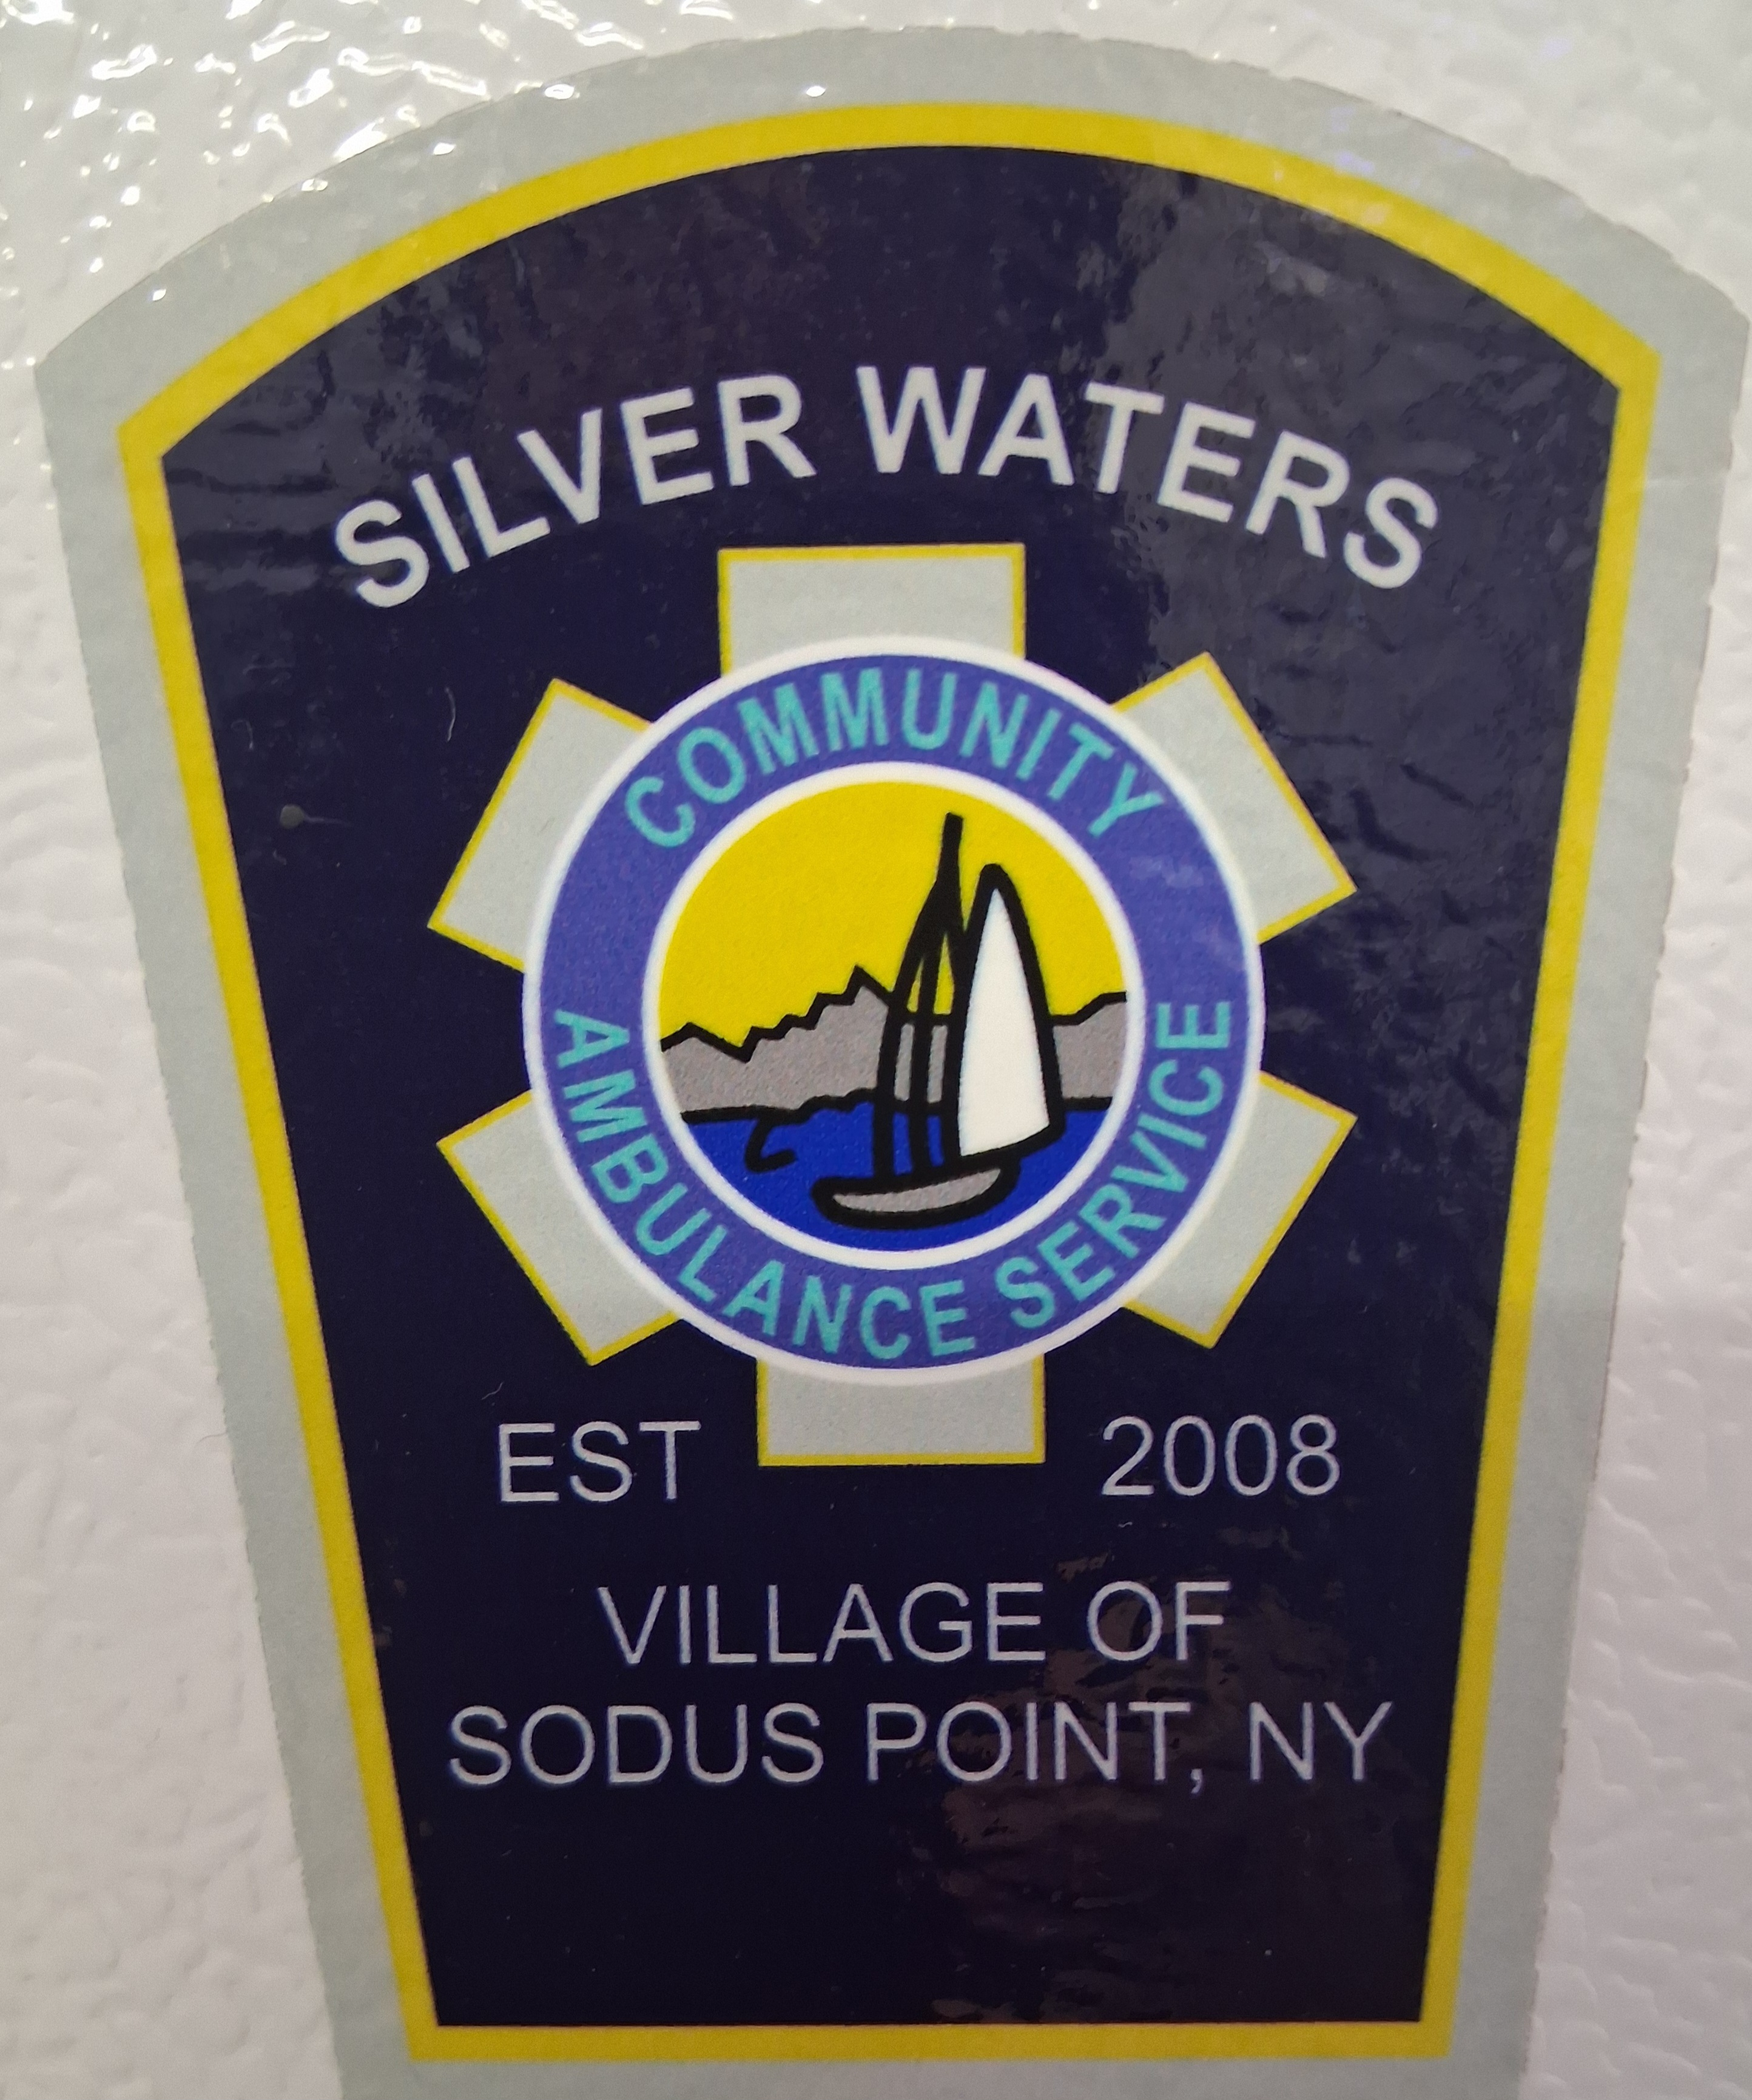
Silver Waters Community

Ambulance Service

8364 Bay Street, PO Box 159
Sodus Point, NY 14555

April 16, 2026

Finger lakes Regional EMS Council, Inc.
63 Pultney Street
Geneva, NY 14456

To Whom It May Concern:

The following members are preceptors with Silver Waters Community Ambulance Service as of January 1, 2026.

William Kallusch EMT

Keith Eygnor EMT (Director of Operations)

Best regards,

Keith R Eygnor
SWCAS Director Of Operations
Ph: 315-807-8494
Fax: 585-551-0608

