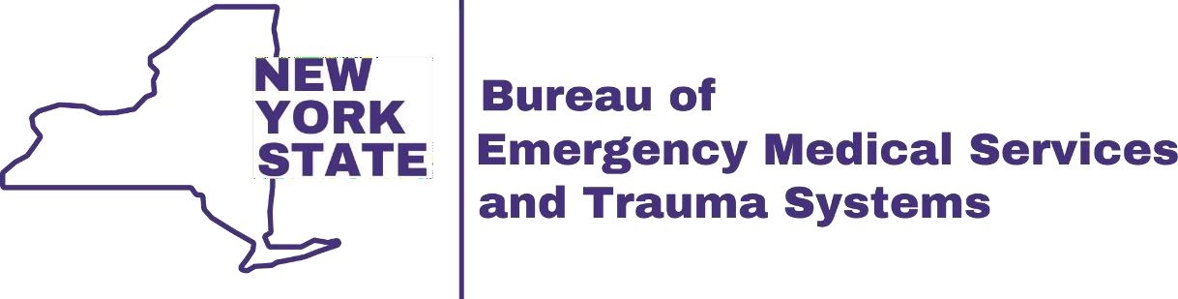

EMS Leadership Training

**For EMS Providers**

## Day 1 – Being the leader people want to follow

* National EMS Management Association 7 Pillars of Leadership
* Developing a learner’s mindset
* Getting to a clean slate
* Manager vs. Leader
* The influence of leadership on culture
* Styles of leadership
* Creating yourself as a leader

## Day 2 – Strategies and applications for the EMS Supervisor

* Creating yourself as the leader you want to be
* Creating a personalized change plan
* Intentionally designing a new culture
* Coaching and mentoring
* Communication
* Leadership in action

# Dates/Times:

Day 1 – Thursday, April 24th, 2025, from 8am – 4pm  
Day 2 – Friday, April 25th, 2025, from 8am – 4pm

# Location:

Finger Lakes Regional EMS Council

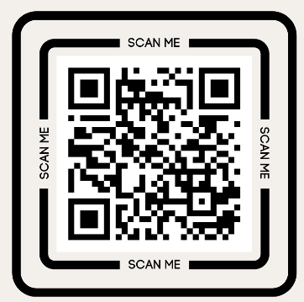63 Pulteney St, Geneva, NY 14456

# Instructor:

Brian Wiedman  
District Chief/Investigator

# Register at:

<https://forms.gle/jpcVFStXhSeXYvf3A>

Lunch will be provided on site. Registration is limited to 30 people. Costs are covered by DOH. For questions, please contact [jvanauker@flremsc.org](mailto:jvanauker@flremsc.org)